Feedback Sheet_For Teacher's & Admin Login

- For the Teacher's Registration Form:
- Replace the 'Marketing Manager' field with 'How did you hear about us?' in the registration form.
- Also, this field has an error as shown below. Kindly check.
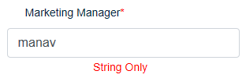
- Ask for the following details in the given order and they all are mandatory to fill.
State:
District:
Town/City:
Pincode:
Street Address:

School Name:
Board:
Your Name:
Designation:
Email Address:
Mobile Number:
How did you hear about us?:

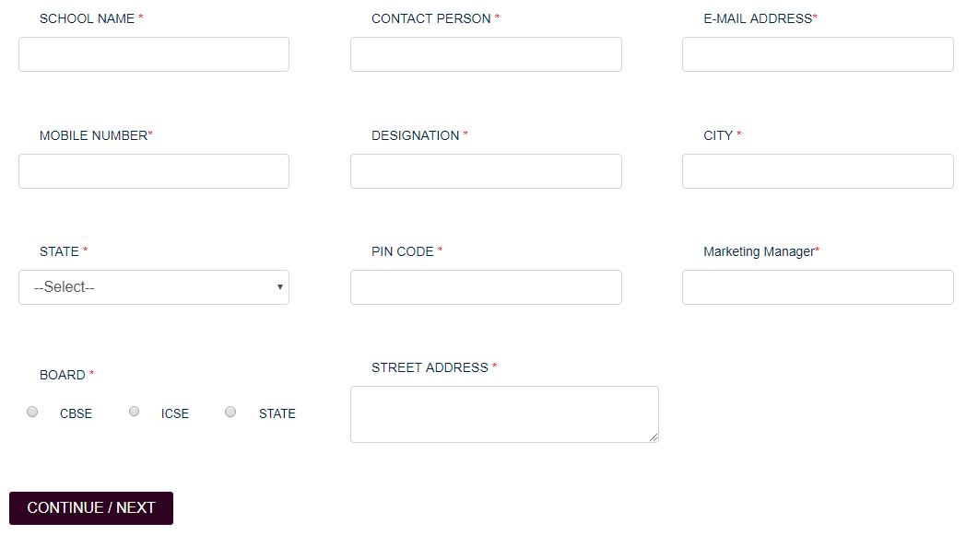
- The following message should be display after the submission of the form.
"Your request has been submitted successfully. Your Username and Password will be sent to your Email address soon."

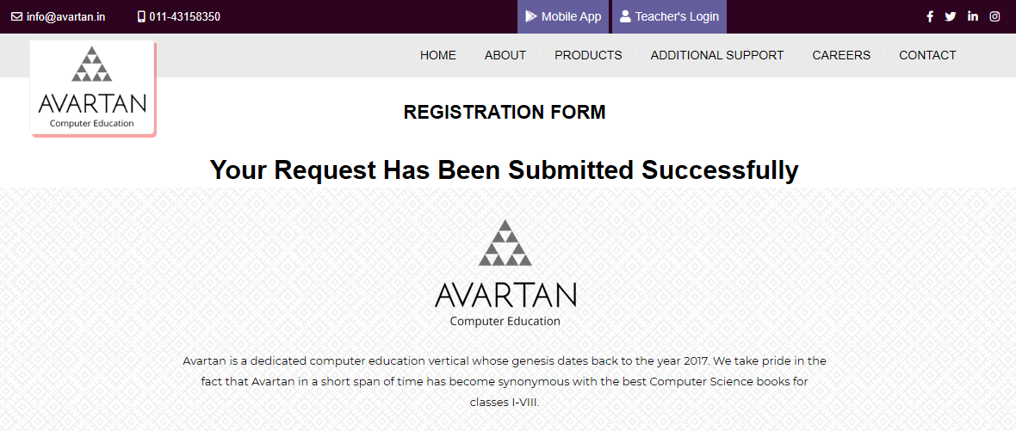

- Teacher's Login
- An error is generating in the following case.
For example, while registering with an emial id: madhus@avartan.in. It is showing the message–"School Already Exists". (1st screenshot)
But when login with the same email id, it is showing–"Invalid User". (2nd screenshot)
Kindly help.
(Note: This email id is once registered and then deleted from the 'superadmin' log.)

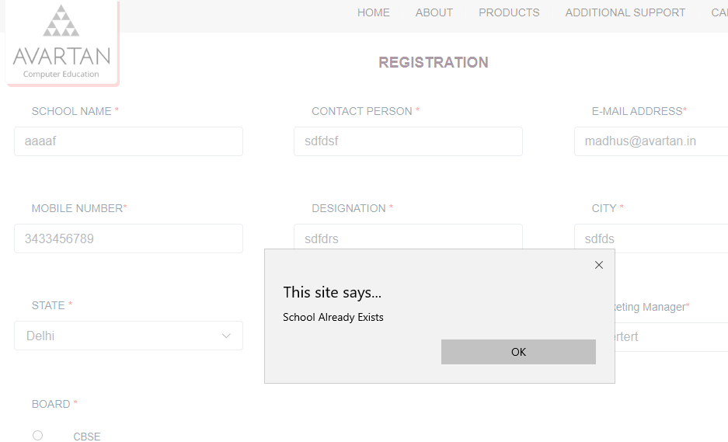
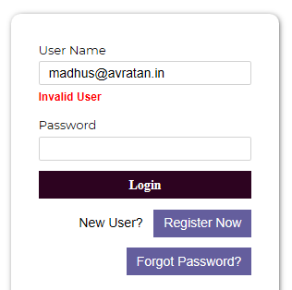

- Wrong downloaded files are showing. Kindly check.
For example, if the admin has granted the permission to school 'aaaa' for Book Class 1 and 2 under the series IT Apps. (1st Screenshot)
Then, under the user mode of 'aaaa', it can download Class 1 for IT Apps and IT Beans also. (2nd Screenshot).

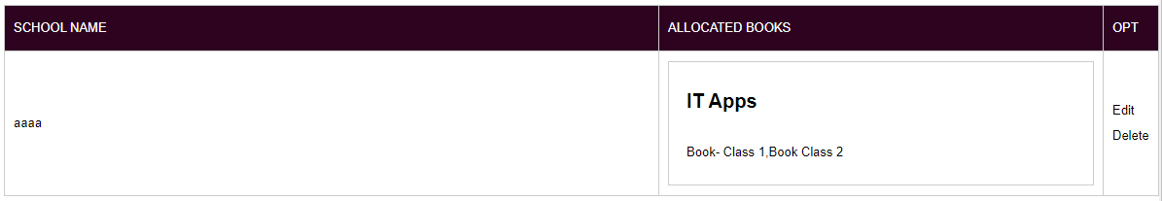
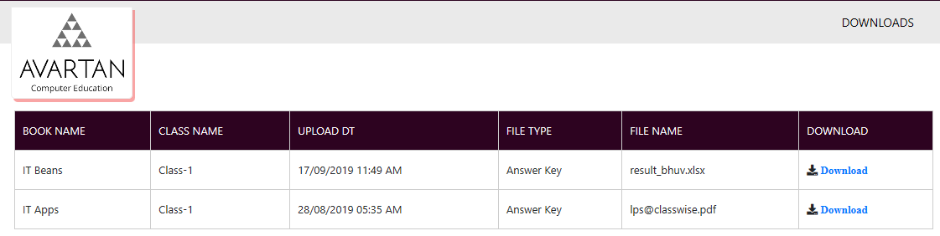

- Admin or Master Mode:
- Books Allocation To School: There is no Minimize, Esc or Close Button for the 'Requested Books' bar as shown below.

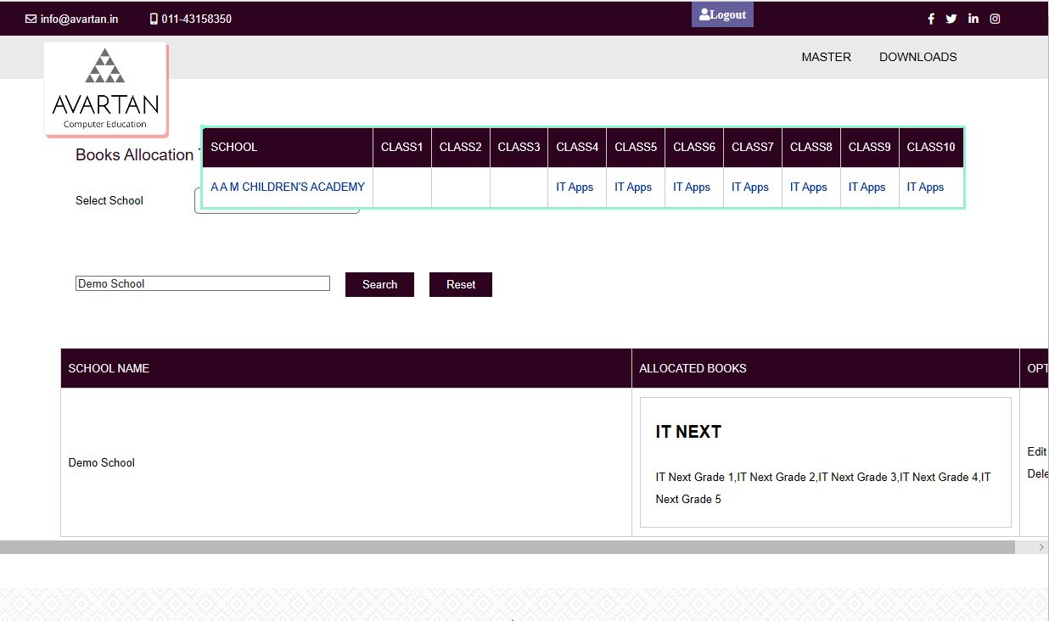
- Options under Master tab: Kindly rearrange the options in the following order:
Manage Schools
Manage Registration Requests
Books Series Master (--> Manage Books Series)
Class Master (--> Manage Books)
Assign Books Under Series
School Books Allocation
Manage Classes
Manage Class Books
Upload Document (--> Upload Documents)

- Class Master (Manage Books): Page numbers are not correctly displaying. Kindly check.
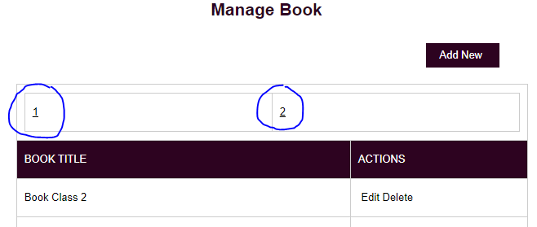
- Functionalities of "Manage Classes" are not clear. Also under "Manage Class Books" tab, 'BOOK' and 'CLASS NAME' fields are also not clear. Kindly Discuss.

- Upload Documents:
  - Kindly check the text shown below. Text shouldn't get cropped.
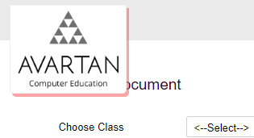
  - There will be four types of documents will be uploaded.
i. Lesson Plan
ii. Answer Key
iii. Worksheet
iv. Additional Questions
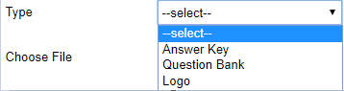
  - Kindly add the feature to add a new type of file here. (Discuss)

- Manage School Requests: Add the following fields also for the Admin to fill, while accepting the school request and these are mandatory to fill. (Discuss this feature)
  - Instead of 'Associate', use the field name 'Sales Representative'
  - Type of Verification:
  - School Code or MCM:
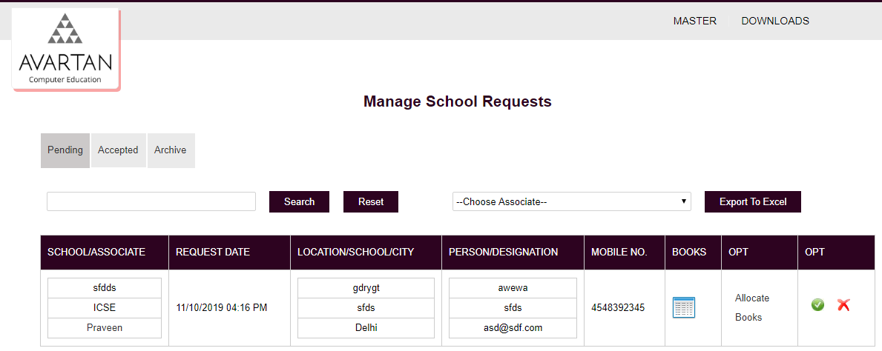

Pre-approved Ids:

- Manage Schools: Fields shoud be in the following order for the Admin to fill details.
State: (Mandatory)
District: (Mandatory)
Town/City:
Pincode:
Street Address:
Sales Representative: (Mandatory)

School Name: (Mandatory)
Board:
Contact Person:
Designation:
Email Address/Username: (Kindly discuss this feature) Mandatory
Password: (Mandatory)
Mobile Number:
Type of Verification: (Mandatory)
School Code/MCM: (Mandatory)

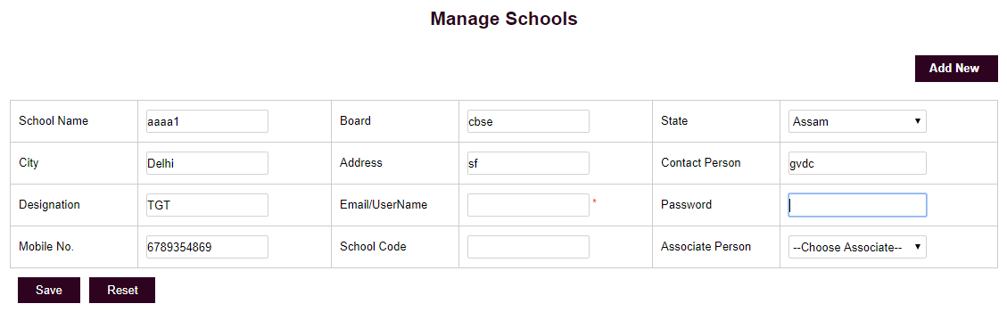

- Email Address/Username: Undre pre-approved id, the admin can give any username (not email address) for login. When the user login with this pre-approved id for the very first time, he/she will see the Registration Form first. And after filling up all the details, they can access the user mode.
(Note: Now, Username will get replaced by the email id added by the user.)
Kindly discuss this feature.

